Lab Assignment

Imports, Functions and Variables

Part A

* **Problem A.1**

Code:

Results:

* **Problem A.2**

Code:

Results:

* **Problem A.3**

Code:

Results:

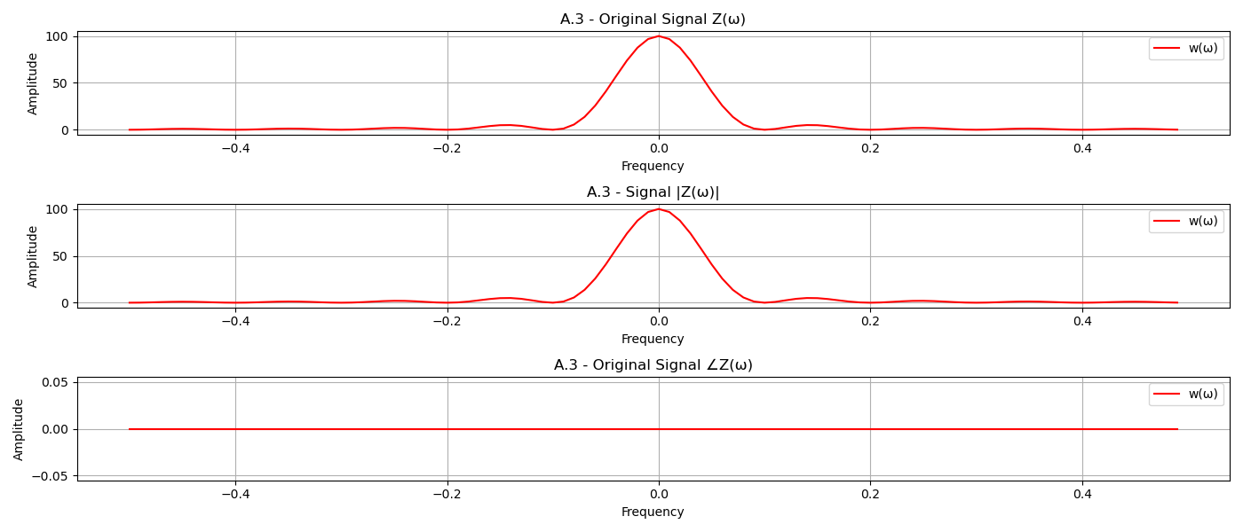

* **Problem A.4**

Code:

Results: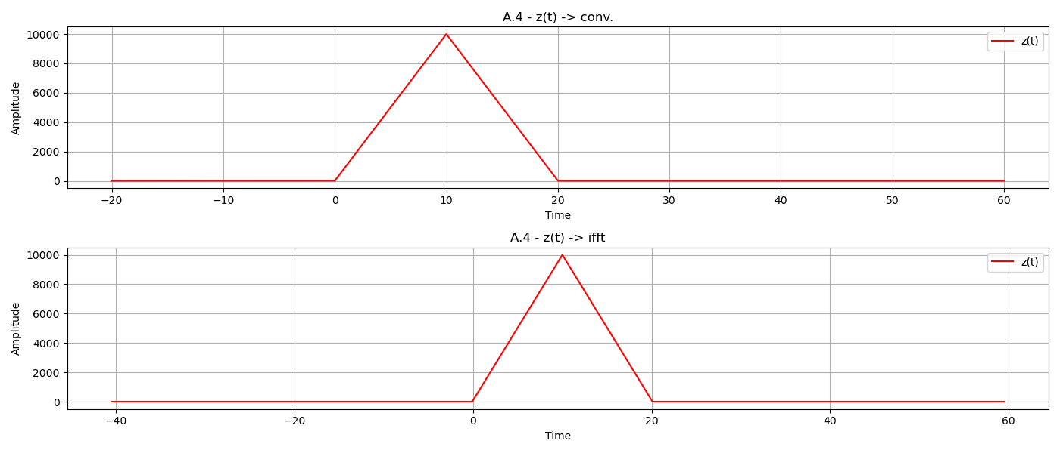

* **Problem A.5**

Code:

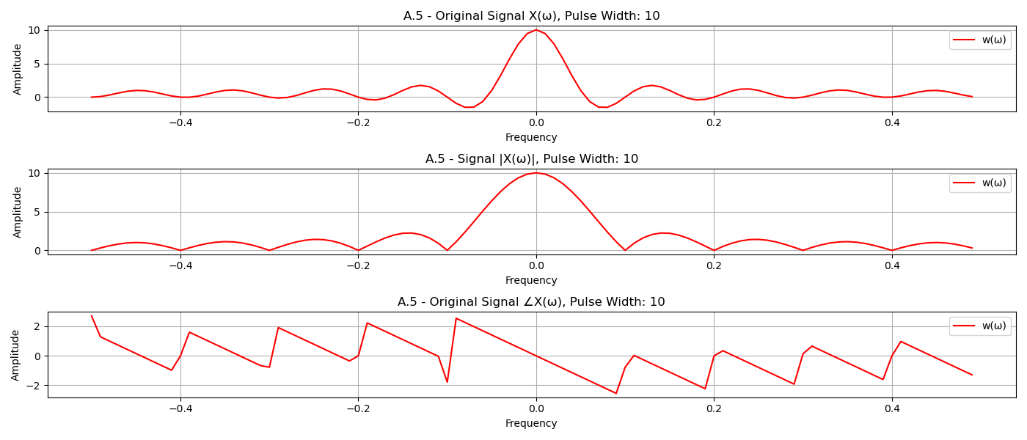

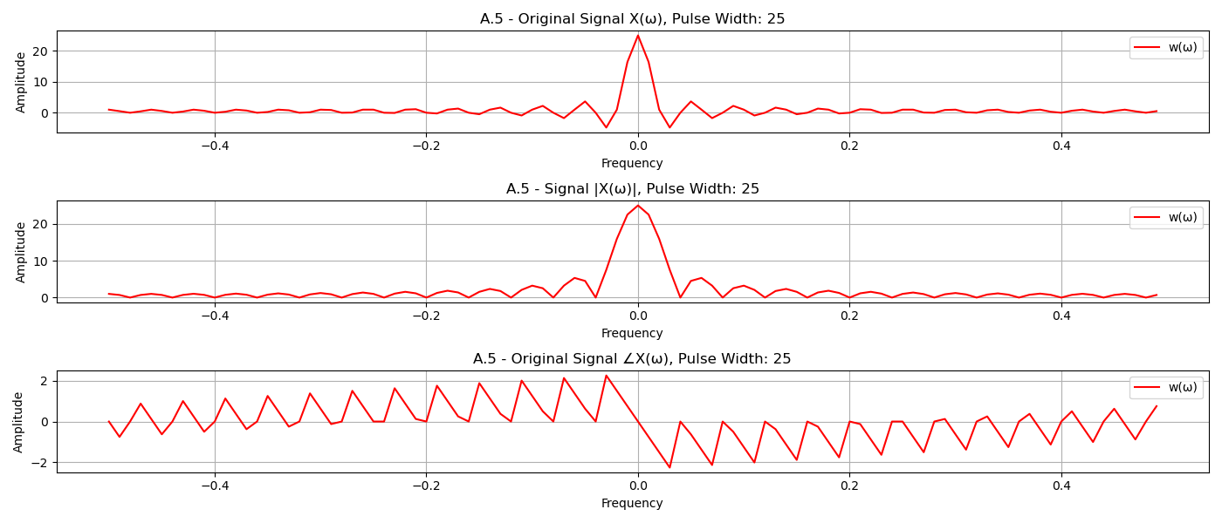

* **Problem A.6**

Code:

Results:

Zf=

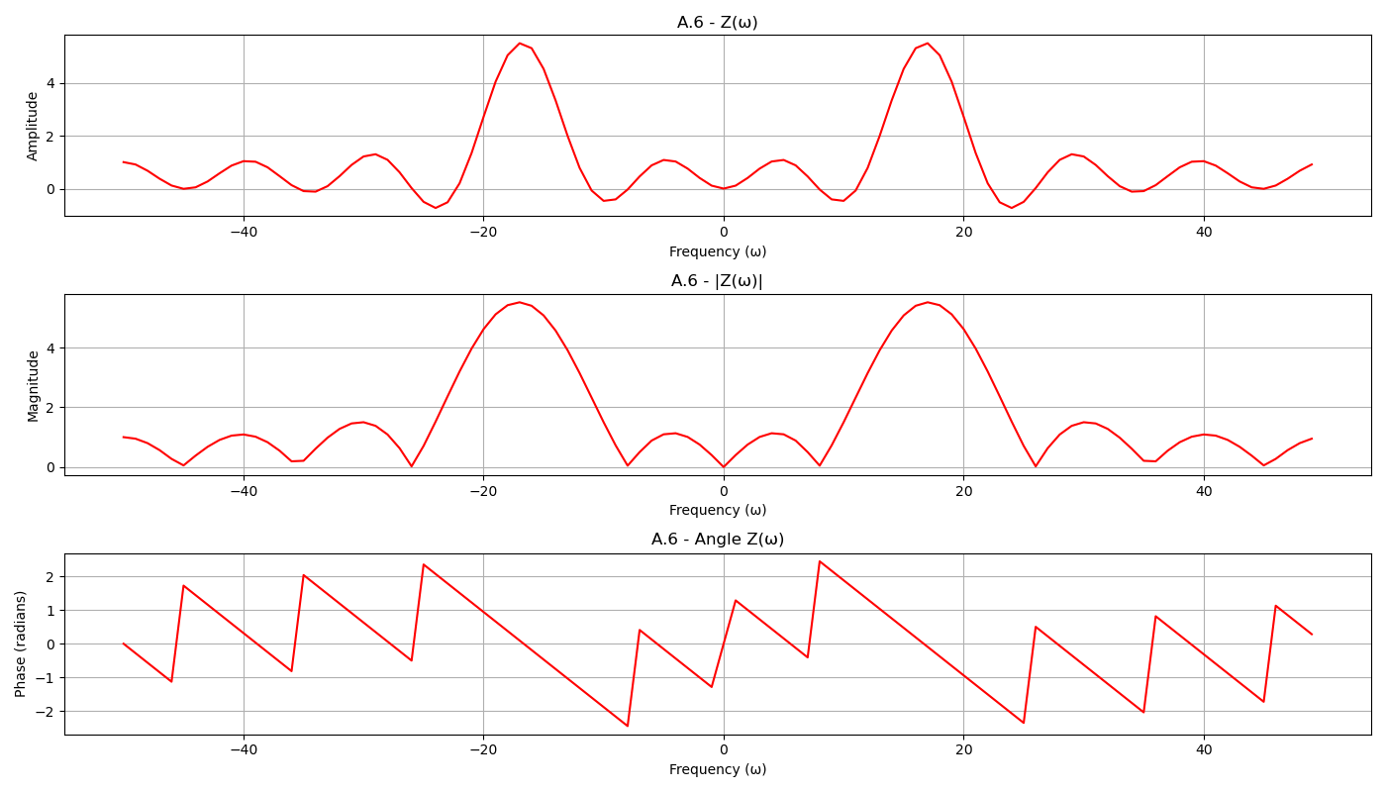

Part B. Application of the Fourier Transform

* **Problem B.1**

Code:

* Results:

Initial Analysis:

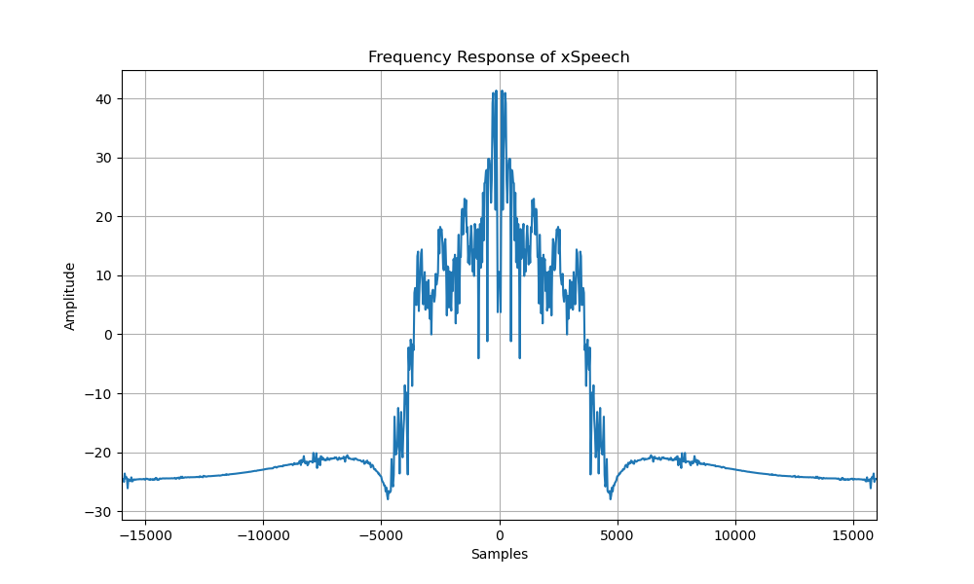

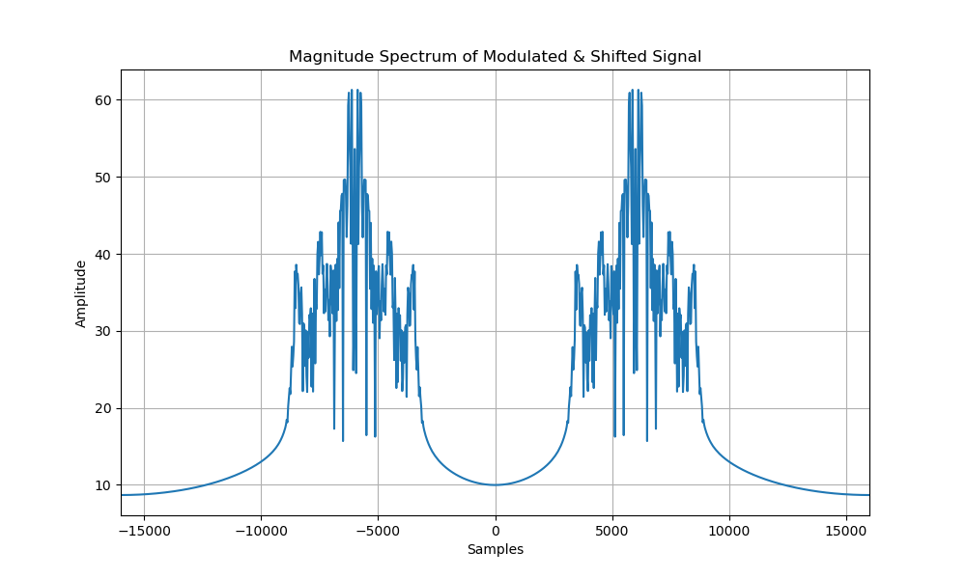

Decoding:

